MTH 337
Report 3
Mayfly Model Exploration
by Tejas Vyas

Table of Contents
INTRODUCTION 3
ASSIGNMENT DETAILS 3
PROCEDURE 4
RESULTS 6
ANALYSIS and CONCLUSION 7
FURTHER ANALYSIS 10
SOURCE CODE 11

INTRODUCTION
"Mayfly model" is a discrete-time model of mayfly population dynamics explained in class. Mayflies are essentially aquatic insects usually present throughout the world in freshwater environments providing them a clean resource and habitat for reproduction and hatching.
Because all mayflies generally mature during a course of 24 hours around Spring or Fall, the population of mayflies gets increased enormously, swarming throughout the nearby areas. Since the lifetime of mayflies is very limited and most of them die within a really short span.
Because of the huge number, they are present everywhere in the area around their hatching for several days with swarms so big that they are similar to a large weather change pattern effectively disguising themselves as a storm on the radar.
Since the population has such rapid changes, the model of population change in mayflies can be studied deterministically to provide an insight to future possible population changes.

ASSIGNMENT DETAILS
In this assignment, using Python, we're trying to observe the population changes in mayflies and their direct correlation with the growth rate. Our task is analyze the changes with respect to growth rate in a limited time span (transient behavior) and in the long-term (asymptotic behavior).
During class, we established the following relation between population of mayflies and growth rate each year:
x_{t+1} = b (1−x_{t}) x_{t}
where x_{t} is the mayfly population in year t (as a proportion of the maximum possible population), x_{t+1} is the mayfly population in year t+1 and b is the maximum growth rate (without any limits to population growth).
To accomplish our task, we need to create an algorithm which takes in the time-period for analysis, an initial population and a growth rate finally giving us a plot explaining transient and asymptotic behaviors of the system.

PROCEDURE
Our task to analyze the mayfly model essentially requires us to create 1 single graph which provides us the asymptotic analysis of the system for multiple values of growth rate (b).
We are also going to create a simpler function which provides us the relationship between population(x) and b for a fixed b just taking in consideration the time-period. This essentially would provide us a transient relationship between growth rate and population.
The formula we're using to calculate the value of population is as mentioned above:
x_{t+1} = b (1−x_{t}) x_{t}
Starting with the simpler function for transient behavior analysis here's our pseudo code for the function:

function fixed-b-analysis (input x,b,t){
For all integers b in the range 1 < b < t:
plot x against b
x = b*(1-x)*x
return final value of x
}

Creating a function for analysis of asymptotic relationship between x and b for a time range tmin,tmax with the following pseudo code:

function ranged-b-analysis (input x,b,tmin,tmax){
seperate b in parts from 0 < b < 4.0 #using linspace for this
For all integers k in the range tmin <= k <= tmax:
If k>tmin:
Plot x and b
x = b*(1-x)*x
return x }

We're using linspace in the above algorithm to get a much faster output because of vectorization. To get a really thorough understanding of the model, we have essentially used linspace to provide us 401 parts of b which roughly gives us an increment of 0.01 in the value of b for each iteration. We also used multiple matplotlib properties to get a smoother curve using alpha and ms properties.
Our results are presented below and provide us various stable states as well as boom-bust cycle which exponentially diverges the the population growth in 2 year cycles.

RESULTS

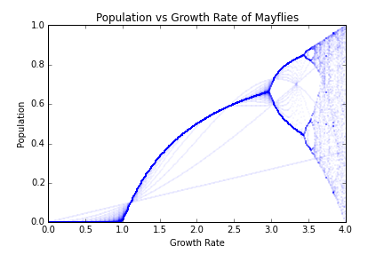
Starting with the broader result, here's the graph which we get for b values from 0 to 4 with population starting at 0.1 and tested for 100 years.
The values of x for each respective b are as follows:
Here's the list of population values for respective growth rates at the end of a 100 year cycle:
At Growth Rate: 0.0 -> Population after 100 years is: 0.0
At Growth Rate: 0.1 -> Population after 100 years is: 8.91016286283e-102
At Growth Rate: 0.2 -> Population after 100 years is: 1.11540605258e-71
At Growth Rate: 0.3 -> Population after 100 years is: 4.46260977638e-54
At Growth Rate: 0.4 -> Population after 100 years is: 1.36234451931e-41
At Growth Rate: 0.5 -> Population after 100 years is: 6.49700086918e-32
At Growth Rate: 0.6 -> Population after 100 years is: 5.15935377911e-24
At Growth Rate: 0.7 -> Population after 100 years is: 2.39036559145e-17
At Growth Rate: 0.8 -> Population after 100 years is: 1.33438814113e-11
At Growth Rate: 0.9 -> Population after 100 years is: 1.29936268281e-06
At Growth Rate: 1.0 -> Population after 100 years is: 0.00889130947666
At Growth Rate: 1.1 -> Population after 100 years is: 0.0909093081063
At Growth Rate: 1.2 -> Population after 100 years is: 0.166666666641
At Growth Rate: 1.3 -> Population after 100 years is: 0.230769230769
At Growth Rate: 1.4 -> Population after 100 years is: 0.285714285714
At Growth Rate: 1.5 -> Population after 100 years is: 0.333333333333
At Growth Rate: 1.6 -> Population after 100 years is: 0.375
At Growth Rate: 1.7 -> Population after 100 years is: 0.411764705882
At Growth Rate: 1.8 -> Population after 100 years is: 0.444444444444
At Growth Rate: 1.9 -> Population after 100 years is: 0.473684210526
At Growth Rate: 2.0 -> Population after 100 years is: 0.5
At Growth Rate: 2.1 -> Population after 100 years is: 0.52380952381
At Growth Rate: 2.2 -> Population after 100 years is: 0.545454545455
At Growth Rate: 2.3 -> Population after 100 years is: 0.565217391304
At Growth Rate: 2.4 -> Population after 100 years is: 0.583333333333
At Growth Rate: 2.5 -> Population after 100 years is: 0.6
At Growth Rate: 2.6 -> Population after 100 years is: 0.615384615385
At Growth Rate: 2.7 -> Population after 100 years is: 0.62962962963
At Growth Rate: 2.8 -> Population after 100 years is: 0.642857142835
At Growth Rate: 2.9 -> Population after 100 years is: 0.655170437177
At Growth Rate: 3.0 -> Population after 100 years is: 0.643772529166
At Growth Rate: 3.1 -> Population after 100 years is: 0.558014125205
At Growth Rate: 3.2 -> Population after 100 years is: 0.513044509533
At Growth Rate: 3.3 -> Population after 100 years is: 0.479427019824
At Growth Rate: 3.4 -> Population after 100 years is: 0.842154378721
At Growth Rate: 3.5 -> Population after 100 years is: 0.826940706591
At Growth Rate: 3.6 -> Population after 100 years is: 0.883217535669
At Growth Rate: 3.7 -> Population after 100 years is: 0.72273029316
At Growth Rate: 3.8 -> Population after 100 years is: 0.195547609648
At Growth Rate: 3.9 -> Population after 100 years is: 0.877537862992
At Growth Rate: 4.0 -> Population after 100 years is: inf.

ANALYSIS and CONCLUSION
In the results above, we can see a certain trend between ranges. The initial population of 0.1 reaches multiple points of stable states and boom-bust cycles. The trend is explained below for each range:

At Growth Rate | Final Population | Explanation
0 | 0 | Transient: With 0 growth rate, after even 1 year we see no new mayflies, thus final population is 0.  Asymptotic: Irregardless of time, with no new hatches, we definitely do not see any more mayflies resulting is a final population of 0
0<b<1.11 | 0<x<0.1 | Transient: With low growth rate, we should see a decline in mayflies in the coming years since the hatching is decreasing with passing time.  Asymptotic: As expected, in a very long time, the population mayflies with continue declining with a decay rate corresponding to respective growth rate. Eventually, after a very long time this will result in a final stable population below the original population because of the exponential decay as depicted in the graph below. This is still decreasing and will eventually reach a point of 0.  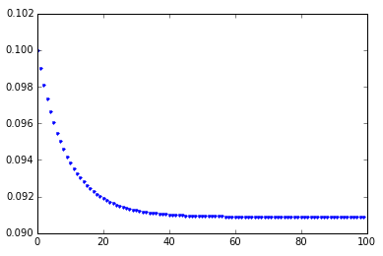
1.11<b<2.5 | 0.1<x<0.6 | Transient: In this period, we see a stable rise is population because of the increased growth rate.  Asymptotic: For a very long time, the population will continue rising eventually reaching a stable point because the death rate of mayfly will eventually catch up to hinder the growth after a certain point. This is depicted in the graph below:  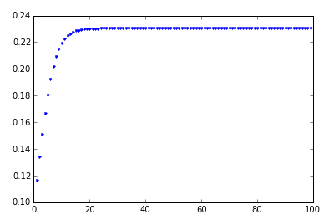
2.5<b<3.3 | 0.1<x<0.5 | Transient: This region of growth rate is essentially cyclical. Starting to increase from a low population, after a certain point, every 2 years we see a rise followed by a drop in population of the mayfly. Eventually during the course of a few years, we see the population reaching a stable cycle where the rise and drop is almost constant throughout 2 years.  Asymptotic: After a very long time, we should see this cyclical behavior continue and thus make up a stable population of mayflies with rise and drop consistent throughout a period of time.  This can be seen below:  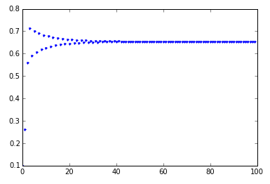
3.4<b<4.0 | 0.1<x<0.85 | Transient: This region is also cyclical, however the rise and drop are not constant and change after every few years.  Asymptotic: This region is the hardest top map asymptotically. Because of the changes not being constant, the cycles every few years will result in a new high and new low population for this subset of time. As growth rate increases, the nature of graph changes and diverges to form further shorter cycles giving a different high and low population level. Since this also essentially follows a recurring pattern, at some point, it should start to act a little more stable and provide a more meaningful idea of population change with respect to growth rate.  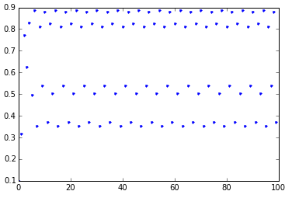
4.0 | inf | As growth rate reach 4 times the original population per year, we're looking at a very rapid increase in population. According to our model, it should essentially be more cyclical with the similar issue of different highs and lows for a sub-period, however, at this point the differences are extremely large and thus Python returns a value of infinity for these calculations.

After analysis of all the above population models, the most stable population appears to be reachable at growth rate of approximately 1.103 which results in the starting population to stay almost perfectly still with the passage of time.

FURTHER ANALYSIS

Any other value of growth rate results in a differential equation which either provides us exponential decay, growth of multiple answers (cycles) based on the rate of change.
As with any differential equation, we can multiple answers based on the constant related to the equation. Also, in this model we did not consider other physical factors which might result in a more conclusive idea of how population changes work in case of mayflies. In our assimilated graph above, we can see multiple faded lines around the original curve. They are essentially the changes we see throughout time, basically the cycles.

SOURCE CODE

import math
from pylab import *

def fixedb(x,b,t):
'''Provides the relationship between a specific growth rate b and population x over time t. '''
for i in xrange(t):
#print x
plot(i,x,'b.')
x = b*(1-x)*x
#print "Final x is:"
return x

def rangedb(x,b,tmin,tmax):
'''Returns a relationship between multiple values of b, x over a certain time period'''
b = linspace(0, b, 401) #Giving us increment of 0.01 per b
for i in xrange(tmax):
if i > tmin:
plot(b, x, 'b.',alpha = 0.5, ms = 0.3)
xlabel('Growth Rate')
ylabel('Population')
title('Population vs Growth Rate of Mayflies')
xlim(0.0,4.0)
ylim(0.0,1.0)
x = b*(1 - x)*x
#for i in range(0,len(b),10): #This code gives the growth rate vs population final result.
# print "At Growth Rate: ", b[i], "-> Population after 100 years is: ", x[i]
return x

fixedb(0.1,0.0,100)
fixedb(0.1,1.11,100)
fixedb(0.1,2.51,100)
fixedb(0.1,3.41,100)
fixedb(0.1,4.0,100)
rangedb(0.1,4.0,0,100)

